Digital services at the forefront of Doka’s Bauma 2019 Campus

Formwork experts, Doka have unveiled a wide range of digital services at this year’s Bauma exhibition, which took place earlier this week in the Bavarian capital of Munich.

Speaking during the official media launch chief executive officer, Harald Ziebula emphasised the importance of designing and launching innovative products and digital solutions as part of the company’s ‘contribution to increase productivity on the construction site.’

Amongst the digital products and services on display was DokaXact, a sensor-based system that supports surveyors and site crews to quickly and precisely position and align wall formwork for automatic climbing systems. The process utilises a measuring system that is attached to defined points on the formwork and communicates wirelessly with a central processing unit. The sensor system is accurate down to +/-2mm, therefore allowing the structure to be built more easily with the predefined structure tolerances. Supported by the DokaXact app that provides step-by-step instructions to the site crew, formwork can be positioned and aligned with pin-point precision for the next casting section. DokaXact was also nominated as a 2019 finalist for the bauma Innovation Award in the components/digital systems category eventually taking third place.

Showcasing the company’s wider approach to digitization, an area entitled ‘Upbeat construction’ focused entirely on the company’s digital offering and was subdivided into three areas, namely Smart Construction Site, Smart Assistants and Smart Planning.

Commenting on the bauma experience, Harald Ziebula, CEO Doka said, “Every three years we have the chance to show our products and services at bauma. One important topic this year is how to increase productivity on site in relation to formwork and cast-in place concrete. With upbeat construction – digital services for higher productivity, we’ll show our contribution to increase productivity.”

Covering 4,700m², this year’s Doka Campus included the presence of Doka's sister company, Umdasch Group Ventures that focuses on future trends and new technology in construction and specialises exclusively on developing ground-breaking, potentially disruptive innovations.

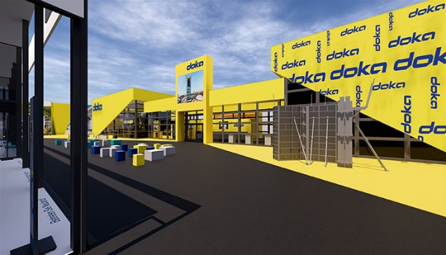 | Doka Campus will present the latest products, services and innovations from the world of formwork at its 4,700 m² booth.  Photo: Doka Campus.jpg  Copyright: Doka

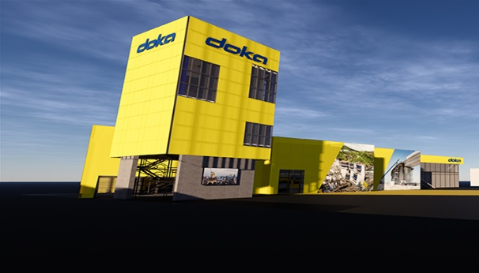 | In the Engineering Tower, visitors will experience different scenarios on two levels using VR technology. In addition, the innovative new DokaXact will be presented.  Photo: Engineering Tower.jpg  Copyright: Doka

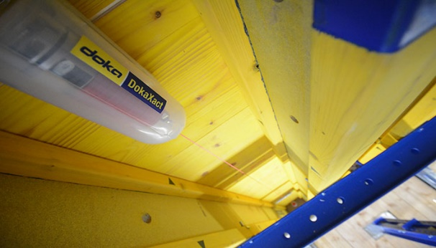 | DokaXact is an interactive, sensor-based system for precise positioning of wall formwork elements for highrise cores.  Photo: DokaXact_Sensor.jpg  Copyright: Doka

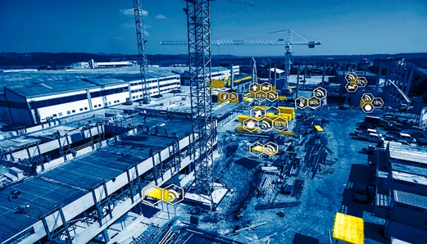 | With a proprietary developed platform and IoT sensors at the site, Doka Contakt provides live data from the construction site.  Photo: Doka Contakt.jpg  Copyright: Doka

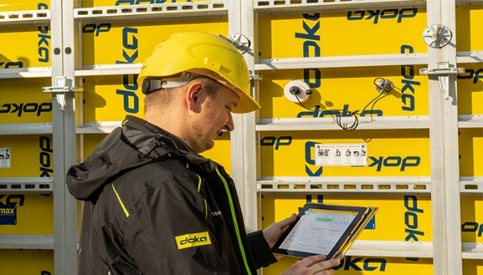 | Concremote enables users not only to plan construction projects better but also provides access to real-time data from any location around the clock. This makes it possible to draw conclusions about concrete performance and take the necessary construction steps at the right time.  Photo: Concremote.jpg  Copyright: Doka

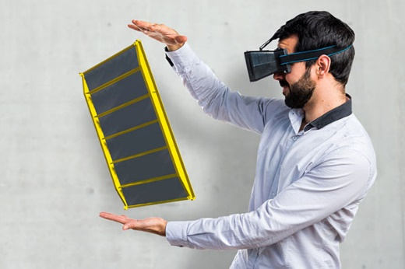 | With the Doka AR-VR app, customers can experience selected Doka solutions in augmented and virtual reality.  Photo: Doka AR-VR-App.jpg  Copyright: Doka

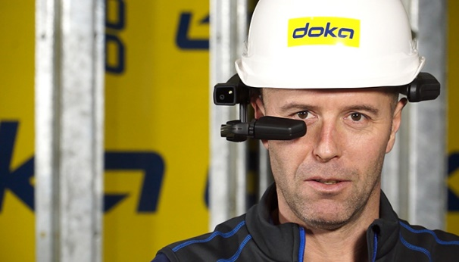 | Remote Instructor facilitates efficient exchange between customers and Doka experts and can be used hands-free via a head-mounted tablet.  Photo: Remote Instructor.jpg  Copyright: Doka

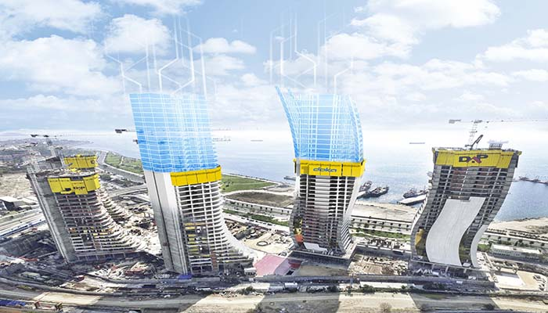 | For Doka, virtual construction means that thanks to  VDC/BIM, formwork solutions can be aligned even more accurately with the construction process for a building.  Photo: BIM.jpg  Copyright: Doka

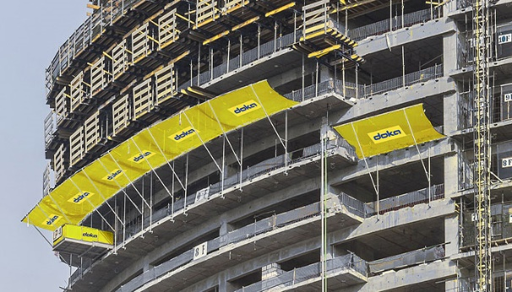 | The three-layer Safety Net Fan SNF is a material collection screen for every building structure.  Photo: Sicherheitsnetz SNF.jpg  Copyright: Doka

About Doka:
Doka is a world leader in developing, manufacturing and distributing formwork technology for use in all fields of the construction sector. With more than 160 sales and logistics facilities in over 70 countries, Doka has a high-performing distribution network. It ensures that equipment and technical support are provided swiftly and professionally. Doka is an Umdasch Group company with a workforce of more than 6,700 employees worldwide.

About Umdasch Group Ventures:
Doka's sister company, Umdasch Group Ventures, focuses on future trends and new technology in construction and specialises exclusively on developing groundbreaking, potentially disruptive innovations. In 2019, the innovation incubator Umdasch Group will present the following three new solutions: Contour Crafting (3D construction printing), Neulandt (mobile precast factory specialising in affordable housing) and Contakt (site digitization).

Press contact
Doka Middle East & Africa
Stephanie Lutz
Head of Marketing Middle East & Africa
M +971/56/224/9746
Email: stephanie.lutz@doka.com

